Sample Report application
Design document
Emmanuele Abbenante (emmanuele.abbenante@gmail.com)
22/11/2017

1. Introduction

This document describes the solution used to implement the Sample Report application.
The application was developed using the IDE Eclipse Luna Service Release 2 (4.4.2).

2. Solution design

To achieve code reuse, the application structure is composed by multiple modules.
Moreover the application was implemented using a layered design, which is shown in the following diagram:

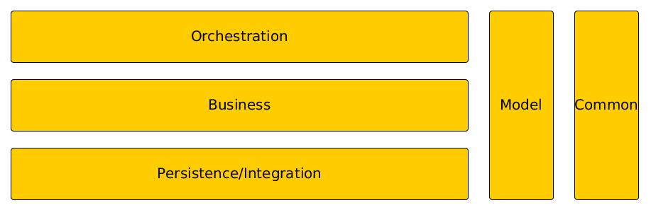

The Orchestration layer calls the services exposed by the business layer to implement the different functionalities of the application. This layer is implemented by the module report-generator, and specifically by the Main class.
The Business layer contains the components that actually implement the application logic. This layer is implemented by the module report-generator. The main components are CountryCurrencyReportService and CountryCurrencyReportExporter.
The Persistence/Integration layer contains the components needed to perform operations on the database and to interact with external systems. The modules report-persistence and webservicex-soap-client fall into this layer, and the main components are CountryCurrencyReportDAO and CountrySoapClient, respectively.
The Model implements the object model used by the business logic and it corresponds to the module report-model. It is used by all the application layers.
Common contains architectural components/utilities used by the other layers. It corresponds to the module common.

The following diagram gives an overview of the relations between the main components of the application.

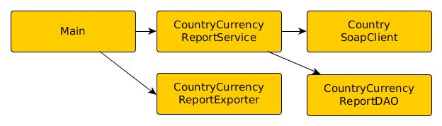

3. Modules

3.1 report-generator

This module contains the entry point of the application, that is the Main class. The business components are also put int this module.
The module leverages the Maven Shade plugin in order to generate a single executable jar containing also the classes from the dependencies.
The CountryCurrencyReportService component main duties are to retrieve the data from the Country web service and to store and retrieve them from the report database.
The CountryCurrencyReportExporter component allows to export the report data in both CSV and XLS formats.

3.2 webservicex-soap-client

This module contains the SOAP client related to the Country web service exposed by the WebserviceX.NET provider.
The module uses the Maven CXF Codegen plugin to generate the web service bindings from the WSDL.

3.3 report-persistence

This module contains the components to manage the persistence operations. The JDBC configuration is put in the file src/main/resources/jdbc.properties.
The module contains the class AbstractReportDAO, which is designed as the parent class of any DAO related to the report database. It provides a protected method to instantiate a JDBC connection.
The DDL for the report data table is defined in the file src/main/script/sql/COUNTRIES_CURRENCIES_REPORT DDL.sql.

